VITAL SECURITY PLC

Payroll Management System

Project Overview & System Design Document

Prepared for internal review
Human Resources, Attendance & Payroll Module — Requirements, Access Control & Workflow Specification

CONFIDENTIAL — INTERNAL USE ONLY

Table of Contents

1. Executive Summary
Vital Security PLC operates a workforce of field-deployed security guards and office staff across multiple client sites. Managing their attendance, scheduling, and payroll accurately — and protecting that process against manipulation — is a direct financial and operational control concern for the company.
This document describes the Payroll Management System currently being built: what it does today, how access is controlled, why each control exists, and how it fits into a broader Enterprise Resource Planning (ERP) system planned for the company going forward.
The document is organized in two parts:
- Part One gives a brief overview of the full ERP vision — what the complete system will eventually look like once all planned modules are built.
- Part Two is the detailed specification of what is actually built and tested today: the Human Resources, Attendance, and Payroll module, including the guard relief-chain system designed specifically to close a known fraud gap in manual attendance record-keeping.

Why this document exists
This is not just a feature list. Every access control and workflow rule described here exists to solve a specific, real problem — most importantly, preventing unauthorized manipulation of guard working hours for personal benefit. Where a control exists, this document explains the reasoning behind it so the intent is clear, not just the mechanism.

2. The Full ERP Vision — System Overview
The Payroll Management System is being built as the first module of a larger Enterprise Resource Planning (ERP) system for Vital Security PLC, rather than as a standalone application. This means the underlying architecture is shared across the company's future systems, not rebuilt separately each time a new business function is digitized.

2.1 Why an ERP approach
An ERP unifies data and processes across the company so that every department works from the same source of truth — a guard registered in Human Resources is the same record referenced later by Finance, Site Operations, or (in the future) Fleet Management, rather than re-entered separately in disconnected systems. This avoids duplicated data, inconsistent records, and the reconciliation problems that come from departments keeping their own separate spreadsheets or tools.

2.2 System Architecture Overview
At the center of the system is a Shared Core Layer: common building blocks — user accounts and permissions, organizational structure, audit logging, and an internal event system — that every business module is built on top of. Human Resources & Payroll is the first module built on this core. Finance, Inventory, Sales/CRM, Procurement, Manufacturing, Project Management, and Fleet Management are planned to follow, reusing the same foundation rather than being built from scratch.
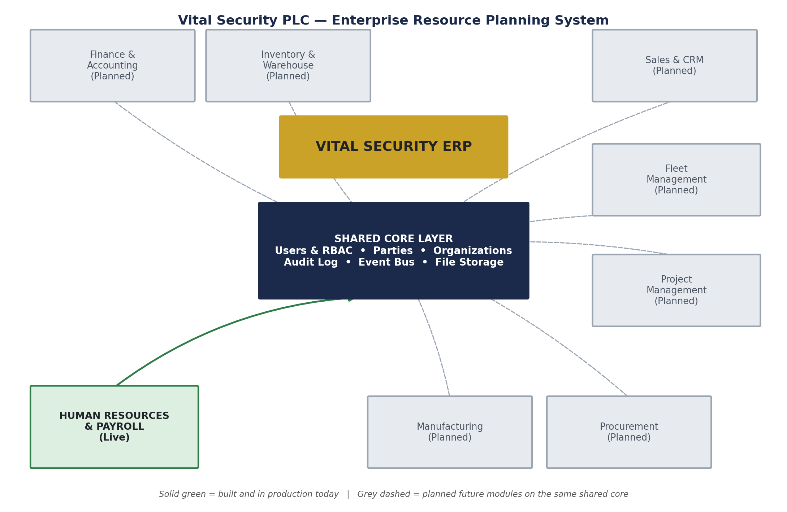
Figure 1 — Vital Security ERP: shared core layer with the Human Resources & Payroll module live today, and seven planned future modules on the same foundation.

2.3 The Shared Core Layer, briefly
- Users & Access Control — every person who logs into any part of the system, and what they're allowed to do, defined once and enforced consistently everywhere.
- Organizations — company, branch, and department structure that future records (invoices, assets, projects) will attach to, not just HR records.
- Audit Log — a permanent, tamper-evident record of who changed what and when, available to every module, not just HR.
- Event System — allows one module to automatically notify another when something relevant happens (for example, a completed payroll run will later be able to automatically notify a future Finance module), without the two modules being tightly wired together.

2.4 Planned Future Modules
The following are planned but not yet built. They appear in the system today only as placeholders, so that the navigation and technical structure required to add them later is already in place.
Module | Purpose
Finance & Accounting | General ledger, accounts payable/receivable, financial reporting — will consume payroll data once built.
Inventory & Warehouse | Equipment, uniforms, and supplies tracking across sites.
Sales & CRM | Client contracts, proposals, and account management.
Procurement | Purchasing and vendor management.
Manufacturing | Report everything in the system across every .
Project Management | Task and resource tracking for internal projects.
Fleet Management | Company vehicle assignment, maintenance, and usage tracking.

These are not part of the current build and are listed here only to give a complete picture of the direction the system is heading.

3. Built & Tested System — Detailed Specification
This section covers what is actually implemented, tested, and running today: the Human Resources, Attendance, and Payroll module. Every workflow and access rule described below is live in the system, not planned or hypothetical.

3.1 Scope of the Current System
- Employee records — for both office staff and security guards
- User accounts and role-based access control
- Site management and guard-to-site assignment
- Attendance tracking, including the guard relief-chain fraud-prevention system
- Payroll processing for both guards (hourly, rate-based) and office staff (salaried), each with a multi-step approval workflow
- A full audit trail and internal event log across all of the above

3.2 Roles & Access Control
Access is controlled by role, and the roles are deliberately designed so that no single person can carry out an entire sensitive process alone — this is the foundation that every workflow in this document is built on.
Role | Represents | What they can do
SUPER_ADMIN | Company owner / senior oversight | Read-only access across the system. Can see everything; cannot directly create, approve, or pay anything. This is intentional — oversight is kept separate from execution.
HR_ADMIN | Human Resources administrator | Creates user accounts and employee records; manages employee data. Cannot assign guards to sites (Operations' responsibility) and cannot process payments.
OPERATIONS | Site & workforce operations | Assigns guards to sites, manages day-to-day scheduling, resolves attendance exceptions (e.g. missed clock-outs). Cannot create user logins and cannot approve or pay payroll.
FINANCE_OFFICER | Payroll & finance processing | Runs the payroll lifecycle end-to-end — rate entry, calculation, checking, approval, and payment. This is the role with the most operational power in the system, which is why its actions are the most heavily audited.
GUARD | Field security guard | Can view and manage only their own shift, hours, sites, payroll, and profile. No administrative access of any kind.

Why roles are split this way
This structure — often called segregation of duties — exists so that manipulating pay or attendance records for personal benefit would require the cooperation of more than one person in more than one role, rather than something one person could quietly do alone. This directly addresses the core concern that motivated this system: past cases where working hours were altered without head office's knowledge.

3.3 Employee & Guard Onboarding Workflow
Bringing a new guard or staff member into the system is deliberately split across three roles, so that the same person who creates a login cannot also decide where that person is deployed.
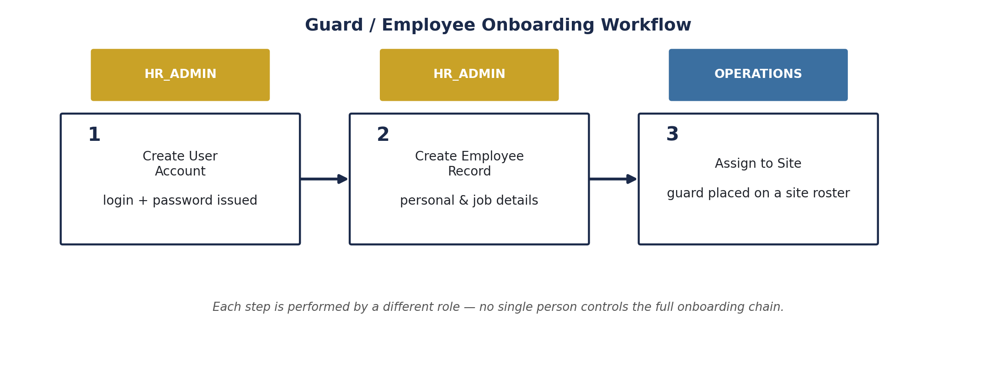
Figure 2 — Onboarding workflow: three steps, three different roles.
Step | Action | Performed by | Detail
1 | Create User Account | HR_ADMIN | Issues a login (email/username + password) for the new person before any other record exists for them.
2 | Create Employee Record | HR_ADMIN | Adds personal details, position, and — for guards — guard-specific information, linked to the user account created in step 1.
3 | Assign to Site | OPERATIONS | Places the guard on a specific site's roster. This is deliberately a separate step performed by Operations, not HR — HR controls identity, Operations controls deployment.

Rationale
Splitting identity creation (HR) from deployment (Operations) means a compromised or careless single account cannot both fabricate a person and place them on a paid site assignment. Each step also writes to the shared audit log, so the full onboarding history for any employee is traceable.

3.4 Attendance & the Guard Relief-Chain System

3.4.1 The Problem
Prior to this system, guard working hours were recorded manually, which created an opening for hours to be added or extended without head office's knowledge or approval — sometimes to benefit the guard, sometimes for other undisclosed reasons. This is a direct financial exposure for the company: unauthorized hours translate directly into unauthorized pay.

3.4.2 The Solution — System-Enforced Relief Chains
Every guard clock-in must now identify exactly which currently on-duty guard is being relieved. The system will not accept the new clock-in unless that specific predecessor has already clocked out. This applies whether a site has one guard or several on duty at the same time — guards are treated as interchangeable at a site, so any guard can relieve any other guard currently on duty there, but the handover itself must always be verified by the system, not taken on trust.
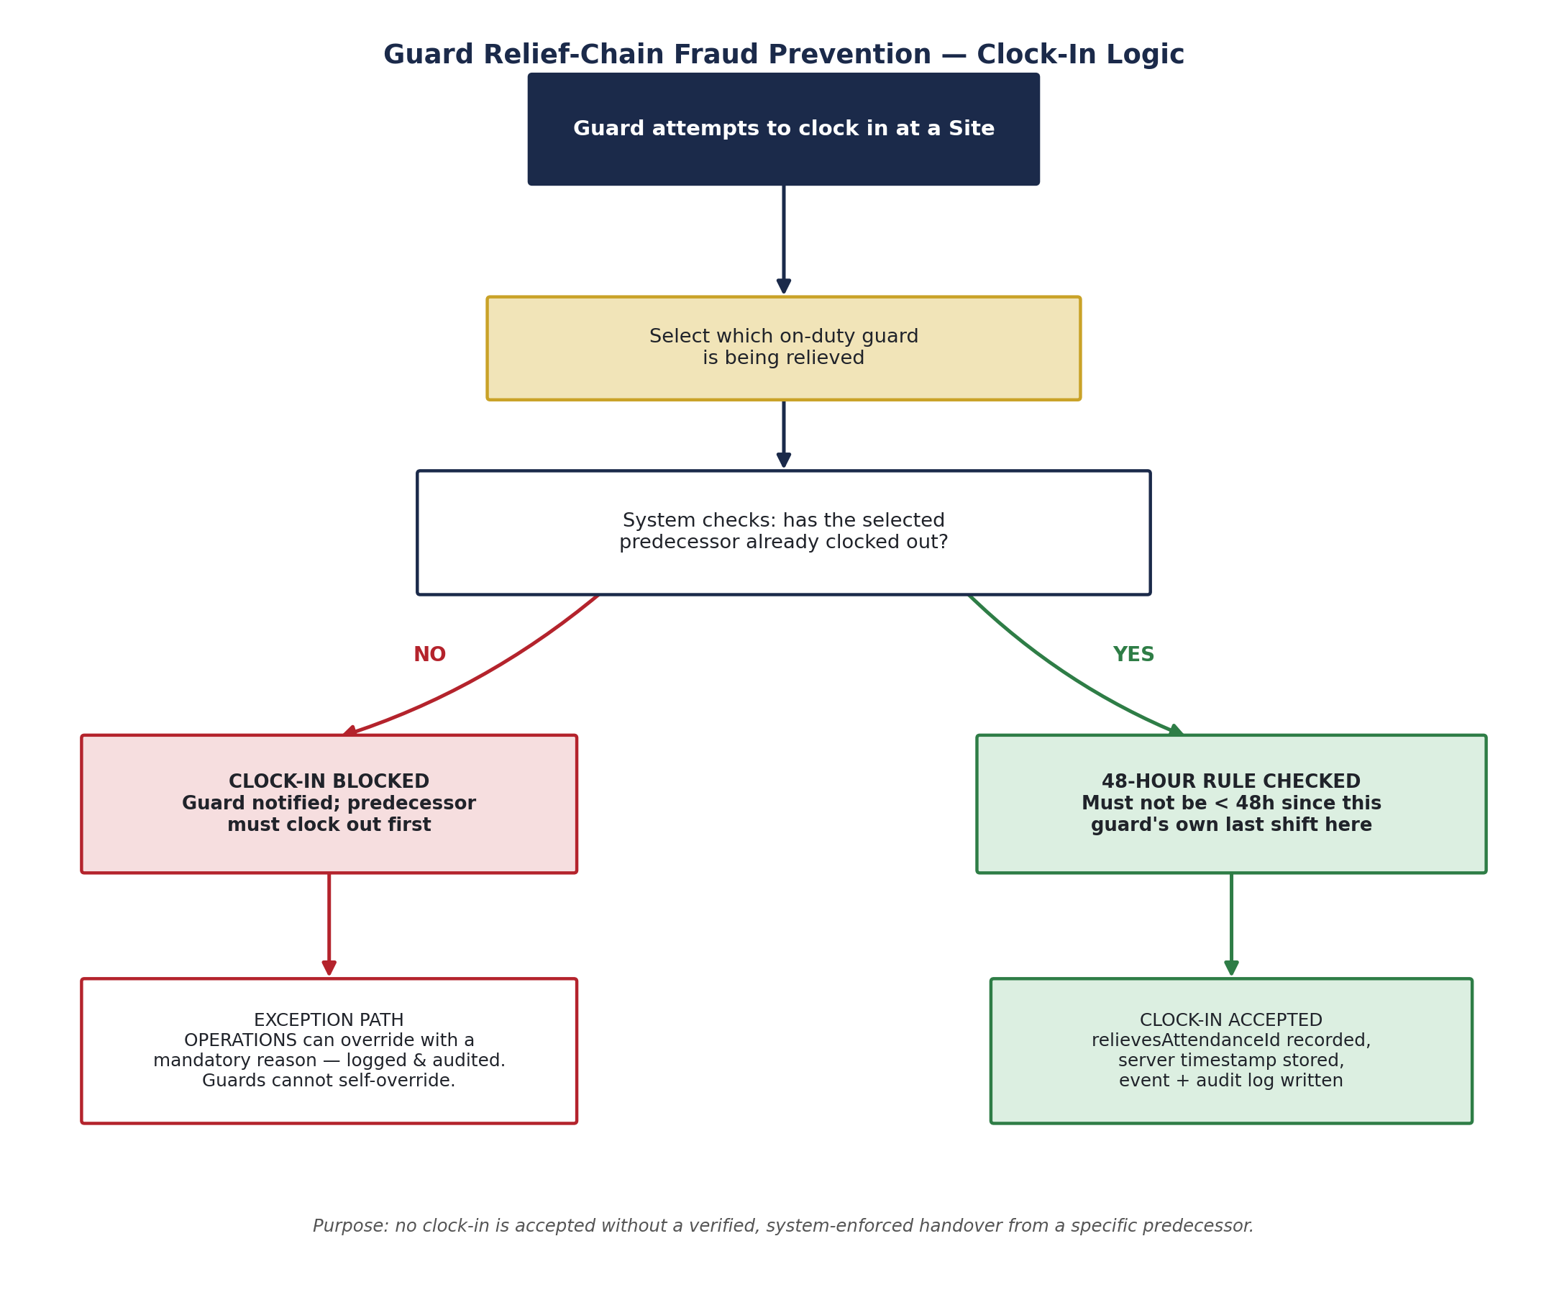
Figure 3 — Clock-in logic: a guard cannot begin a shift without a verified handover from a specific, named predecessor.

3.4.3 The 48-Hour Rule
In addition to the relief-chain check, the system enforces that a guard cannot begin a new shift at a site within 48 hours of their own previous shift there. This reflects a legal rest-period requirement and also closes a related fraud pattern: a guard covering for their own "relief" under a proxy or informal arrangement to effectively work back-to-back shifts unrecorded as such.

3.4.4 Handling Genuine Exceptions
A predecessor guard may occasionally forget to clock out. Rather than allowing guards to resolve this among themselves — which would recreate the exact trust gap the system is meant to close — an exception path requires Operations to manually confirm the predecessor's clock-out, with a mandatory written reason. This action is written to the audit log and raises an internal event, and it cannot be performed by a guard-level account under any circumstance.

3.4.5 Coverage Visibility
Each site has a configured expected guard headcount. If the number of guards actually on duty drops below that expectation, the system raises a visibility alert for Operations and head office. This is intentionally an alert, not a block — the system does not prevent additional guards from clocking in beyond the expected headcount, since there are legitimate operational reasons a site may need temporary extra coverage (an emergency, a handover overlap, training). The goal is informed oversight, not rigid automatic restriction.

3.4.6 Data Integrity Safeguards
- All clock-in and clock-out times are stamped by the server the moment the request is received — never trusted from a guard's phone or device, which could be altered.
- Every clock-in, clock-out, edit, and override is written to the audit log with who performed it and when.
- GPS-verified location capture at clock-in/out is identified as the next planned enhancement to this system, to confirm a guard was physically present at the site, not just that a valid handover occurred.

3.5 Payroll Processing
Guards and office staff are paid under genuinely different logic, so the system runs two parallel payroll pipelines rather than forcing both into one generic process.
- Guard Payroll — calculated from actual hours worked at each site, multiplied by site/role-specific pay rates. This is why rate entry is a distinct step before calculation can happen.
- Staff Payroll — based on fixed salary, with a simpler calculation but the same approval rigor.
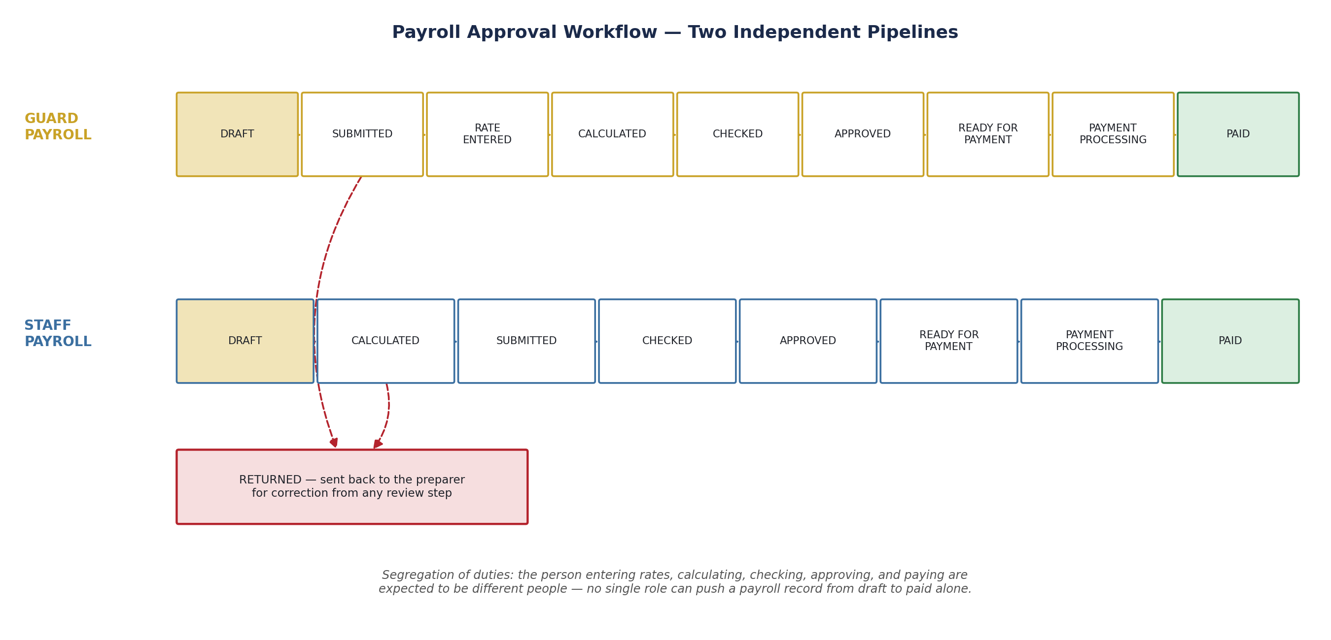
Figure 4 — Payroll approval workflow. Each stage is intended to be actioned by a different person.

3.5.1 Why a Multi-Step Approval Chain
Payroll moves through Draft, (rate entry for guards), Calculation, Checking, Approval, and Payment stages, with a Returned status available at any review point to send a record back for correction. This mirrors standard financial control practice: the person entering source data, the person calculating pay, the person checking the calculation, and the person giving final approval are expected to be different people. No single role can take a payroll record from draft to paid without it passing through independent review.

3.5.2 Access Control on Payroll Actions
Every payroll action — generating a run, entering rates, calculating, submitting, checking, approving, returning, and marking as paid — is individually permission-gated. During development, an audit identified and closed roughly fifteen endpoints that were missing these permission checks; all payroll and attendance actions are now confirmed to require the correct role.

3.6 Audit Logging & Event System
Every meaningful action across employees, sites, guards, attendance, and payroll — creation, updates, approvals, overrides — is written to a shared audit log recording who performed the action and when. This is the same audit mechanism used across the whole system, not a feature specific to one screen, so records can be traced consistently regardless of which part of the system they originated from.
An internal event system also runs alongside the audit log, allowing actions in one part of the system to trigger reactions elsewhere (for example, a completed payroll run emitting an event that a future Finance module could listen for). This is currently used internally and is one of the pieces of shared infrastructure that will make future modules faster to build.

3.7 Additional Technical Safeguards
- Guard registration creates linked records across multiple parts of the system together as a single atomic operation — if any part fails, none of it is saved, preventing half-created guard records.
- Employee ID numbers are generated using a race-safe atomic counter, preventing duplicate IDs even if two guards are registered at the exact same moment.
- All access control is enforced at the server level on every request, not only hidden or disabled in the interface — so access cannot be bypassed by a technically capable user.

4. Design Rationale Summary — Risk to Control Mapping
This table consolidates the reasoning behind the system's major controls in one place, mapping each control directly to the specific risk it is designed to address.
Risk | Control | Why it works
Hours added/altered without head office knowledge | Guard relief-chain — clock-in requires a verified predecessor handover | Makes it structurally impossible for a guard to record hours without a specific, checkable predecessor event.
Guard working excessive back-to-back hours unrecorded | 48-hour rule enforced at clock-in | Blocks a guard from re-starting a shift at the same site too soon after their own last one.
A guard quietly fixing a missed clock-out themselves | Exception path requires Operations, not the guard, with mandatory logged reason | Keeps correction authority with a supervisory role, and creates a permanent record of every such correction.
One person controlling the entire payroll process | Multi-step payroll workflow (rate entry → calculate → check → approve → pay) | Requires independent review before money moves; no single login can complete the full cycle alone.
One person controlling the entire onboarding process | Onboarding split across HR_ADMIN (identity) and OPERATIONS (deployment) | Prevents a single account from both fabricating a person and placing them on a paid assignment.
Unauthorized access to sensitive actions via hidden UI bypass | Server-side permission checks on every request | Access control cannot be bypassed by directly calling the system's backend, only through legitimate, permitted actions.
No way to investigate after the fact if something looks wrong | System-wide audit log + event log | Every sensitive action is traceable to a specific user and timestamp, across every part of the system.
Duplicate or colliding employee ID numbers | Atomic, race-safe ID generation | Guarantees unique employee IDs even under simultaneous registrations.

5. Near-Term Roadmap
The following are identified next steps, in rough priority order, building on the foundation described in this document:
- GPS/location verification at clock-in and clock-out — the most significant remaining gap for confirming a guard's physical presence at a site, not just a valid system handover.
- Recruitment and Performance Management modules — planned additions to the Human Resources module, not yet started.
- Continued adoption of a shared visual design system across all interface screens, so the system looks and feels consistent as new modules are added.
- Finance & Accounting module — the natural next ERP module, given its data already overlaps significantly with the payroll periods and rates this system manages.

6. Document Sign-Off
This document is submitted for review and feedback. Comments, questions, or additional requirements are welcomed and will be incorporated into the next revision.

Role | Name / Signature
Prepared by |  | Date
Reviewed by |  | Date
Approved by |  | Date

